1) ECB (Electronic Codebook)
Aim
To implement DES encryption and decryption using ECB (Electronic Codebook) mode.
Algorithm
- Start the program.
- Read the plaintext from the user.
- Define an 8-byte secret key.
- Create a DES cipher in ECB mode.
- Encrypt the plaintext.
- Display the ciphertext.
- Decrypt the ciphertext.
- Display the original plaintext.
- Stop.

Code:
from Crypto.Cipher import DES
from Crypto.Util.Padding import pad, unpad

key = b"12345678"

cipher = DES.new(key, DES.MODE_ECB)

text = input("Enter Plaintext: ")

ciphertext = cipher.encrypt(pad(text.encode(), DES.block_size))

print("Ciphertext:", ciphertext.hex())

decipher = DES.new(key, DES.MODE_ECB)
plaintext = unpad(decipher.decrypt(ciphertext), DES.block_size)

print("Decrypted:", plaintext.decode())

Result:
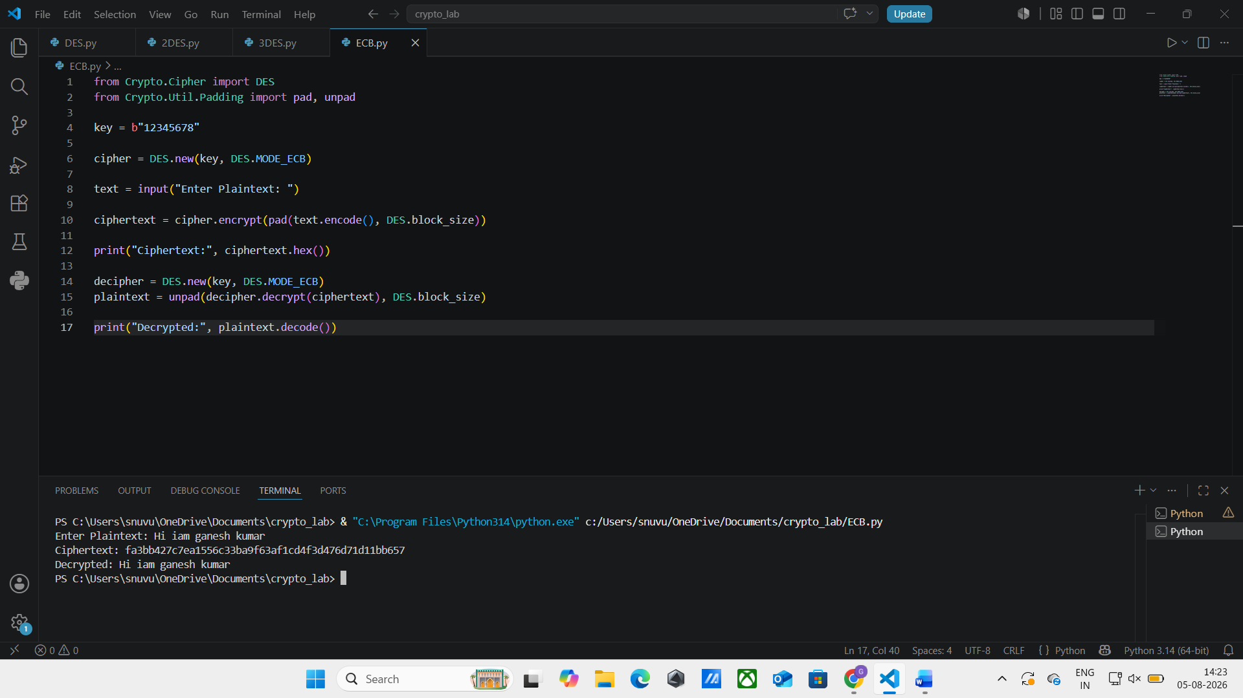

2. DES - CBC (Cipher Block Chaining)
Aim
To implement DES encryption and decryption using CBC (Cipher Block Chaining) mode.
Algorithm
- Start.
- Read plaintext.
- Define an 8-byte key.
- Generate an Initialization Vector (IV).
- Create a DES cipher in CBC mode.
- Encrypt the plaintext.
- Display ciphertext.
- Decrypt using the same IV.
- Display original plaintext.
- Stop.

Code:
from Crypto.Cipher import DES
from Crypto.Util.Padding import pad, unpad
from Crypto.Random import get_random_bytes

key = b"12345678"
iv = get_random_bytes(8)

cipher = DES.new(key, DES.MODE_CBC, iv)

text = input("Enter Plaintext: ")

ciphertext = cipher.encrypt(pad(text.encode(), DES.block_size))

print("IV:", iv.hex())
print("Ciphertext:", ciphertext.hex())

decipher = DES.new(key, DES.MODE_CBC, iv)
plaintext = unpad(decipher.decrypt(ciphertext), DES.block_size)

print("Decrypted:", plaintext.decode())

Result:
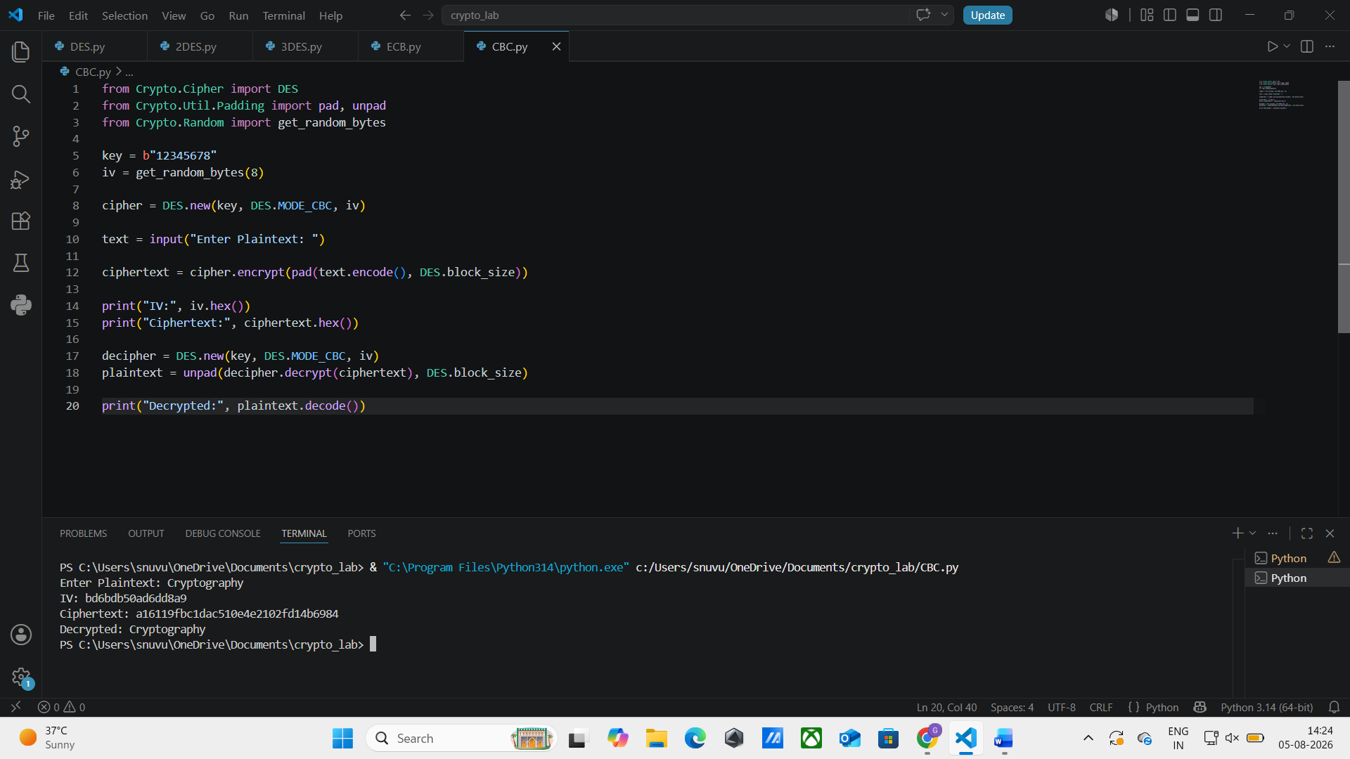

3. DES - CFB (Cipher Feedback)
Aim
To implement DES encryption and decryption using CFB (Cipher Feedback) mode.
Algorithm
- Start.
- Read plaintext.
- Define an 8-byte key.
- Generate an Initialization Vector.
- Create DES cipher in CFB mode.
- Encrypt plaintext.
- Display ciphertext.
- Decrypt ciphertext.
- Display plaintext.
- Stop.

Code:
from Crypto.Cipher import DES
from Crypto.Random import get_random_bytes

key = b"12345678"
iv = get_random_bytes(8)

cipher = DES.new(key, DES.MODE_CFB, iv)

text = input("Enter Plaintext: ")
ciphertext = cipher.encrypt(text.encode())
print("IV:", iv.hex())
print("Ciphertext:", ciphertext.hex())
decipher = DES.new(key, DES.MODE_CFB, iv)
plaintext = decipher.decrypt(ciphertext)
print("Decrypted:", plaintext.decode())

Result:
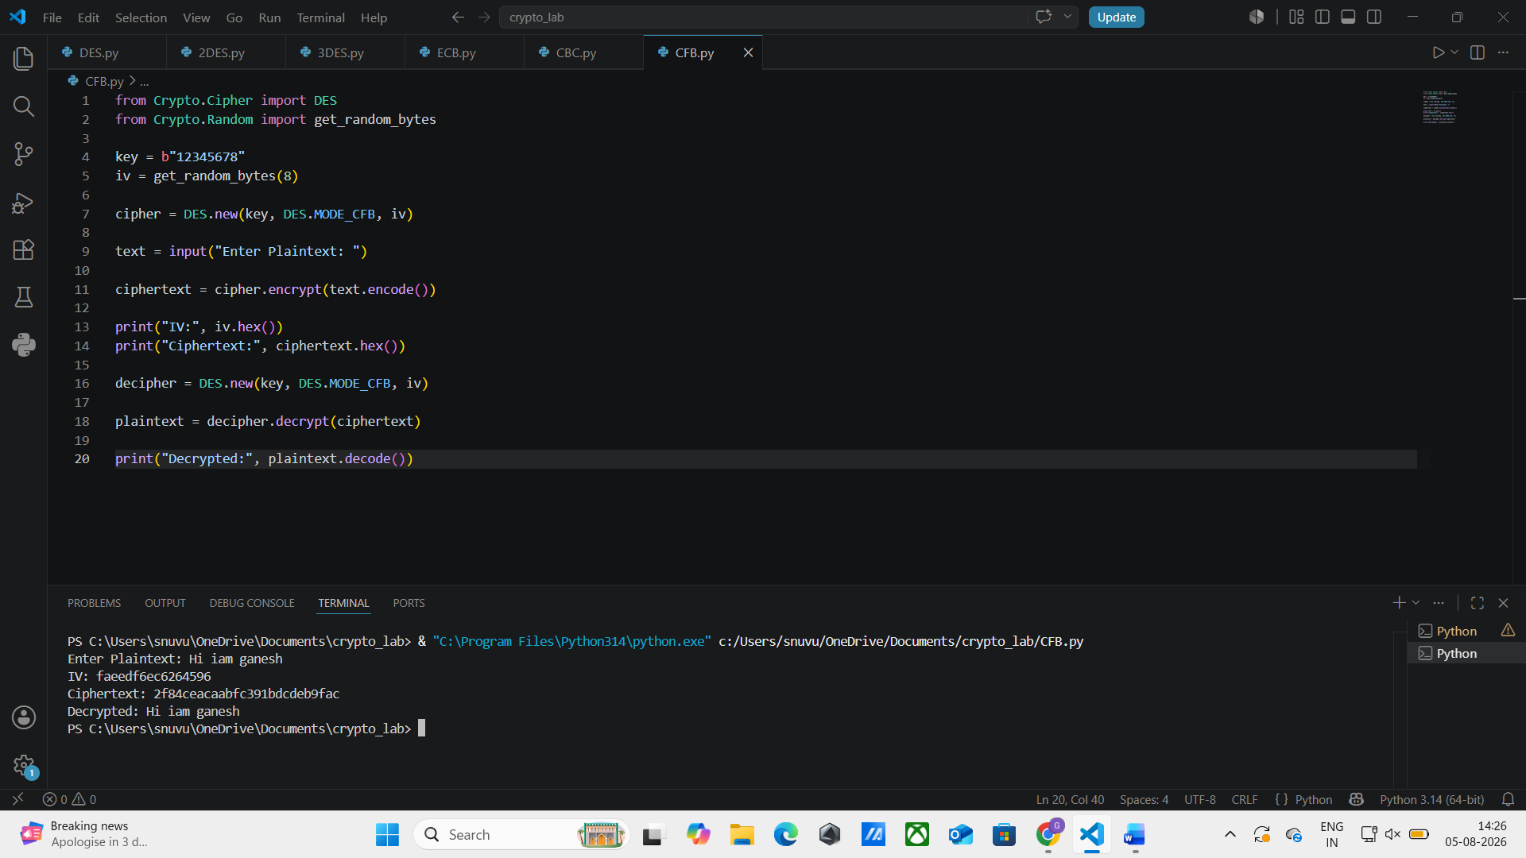
4. DES - OFB (Output Feedback)
Aim
To implement DES encryption and decryption using OFB (Output Feedback) mode.
Algorithm
- Start.
- Read plaintext.
- Define an 8-byte key.
- Generate an Initialization Vector.
- Create DES cipher in OFB mode.
- Encrypt plaintext.
- Display ciphertext.
- Decrypt ciphertext.
- Display original plaintext.
- Stop.
Code:
from Crypto.Cipher import DES
from Crypto.Random import get_random_bytes

key = b"12345678"
iv = get_random_bytes(8)

cipher = DES.new(key, DES.MODE_OFB, iv)

text = input("Enter Plaintext: ")

ciphertext = cipher.encrypt(text.encode())

print("IV:", iv.hex())
print("Ciphertext:", ciphertext.hex())

decipher = DES.new(key, DES.MODE_OFB, iv)

plaintext = decipher.decrypt(ciphertext)

print("Decrypted:", plaintext.decode())

Result:
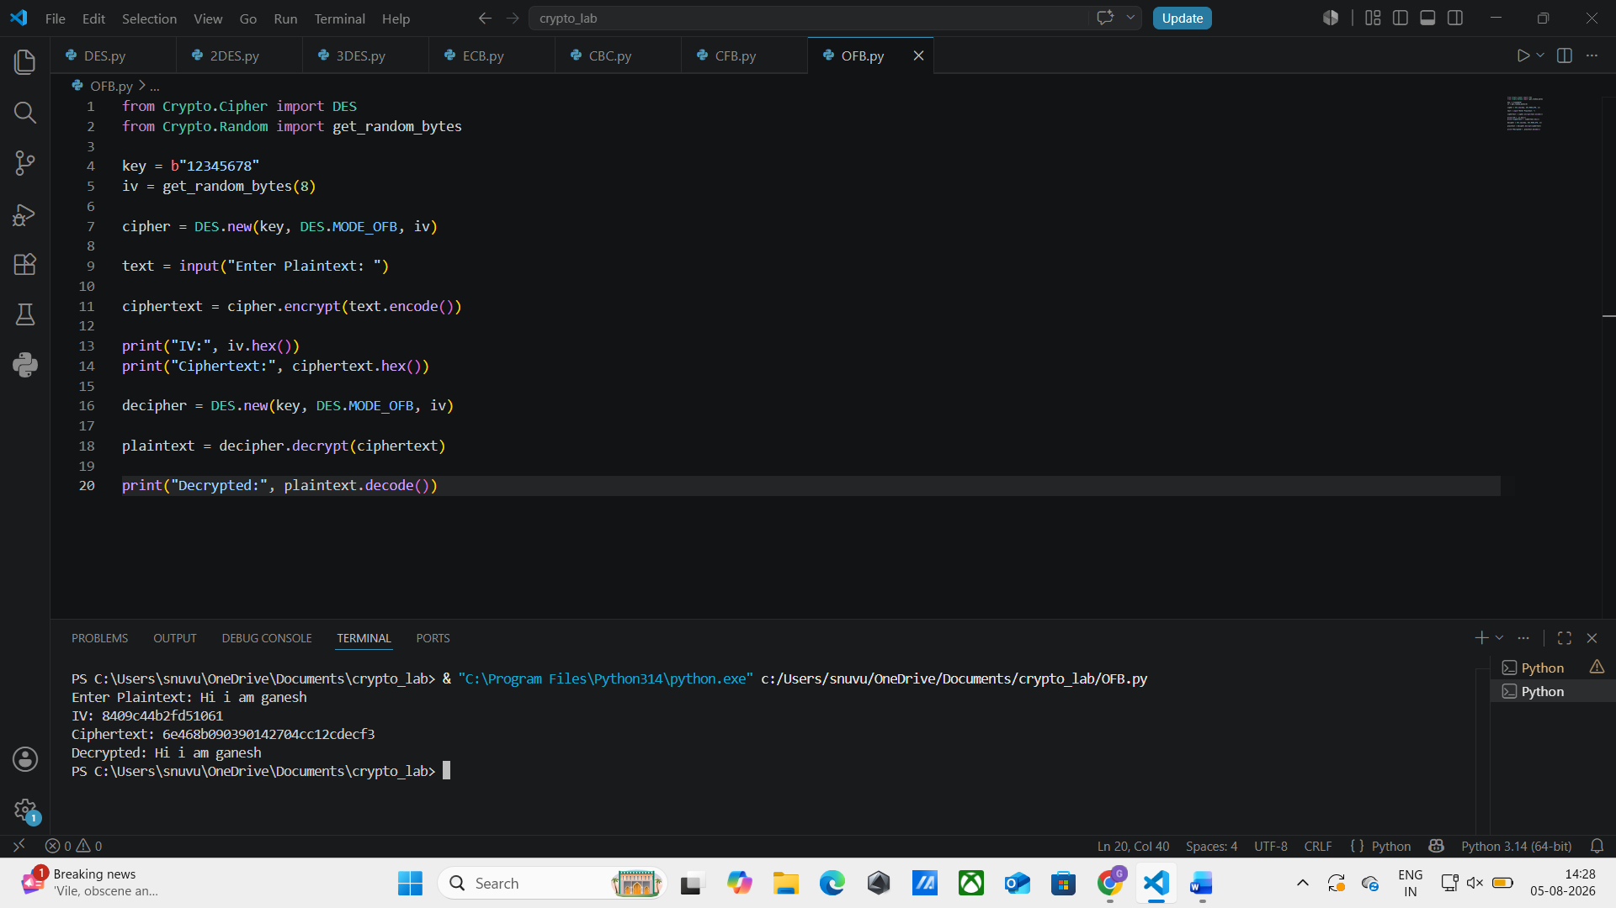

5. DES - CTR (Counter Mode)
Aim
To implement DES encryption and decryption using CTR (Counter) mode.
Algorithm
- Start.
- Read plaintext.
- Define an 8-byte key.
- Create a counter object.
- Create DES cipher in CTR mode.
- Encrypt plaintext.
- Display ciphertext.
- Recreate the counter.
- Decrypt ciphertext.
- Display original plaintext.
- Stop.

Code:
from Crypto.Cipher import DES
from Crypto.Util import Counter

key = b"12345678"

ctr = Counter.new(64)

cipher = DES.new(key, DES.MODE_CTR, counter=ctr)

text = input("Enter Plaintext: ")

ciphertext = cipher.encrypt(text.encode())

print("Ciphertext:", ciphertext.hex())

ctr = Counter.new(64)

decipher = DES.new(key, DES.MODE_CTR, counter=ctr)

plaintext = decipher.decrypt(ciphertext)

print("Decrypted:", plaintext.decode())

Result:
